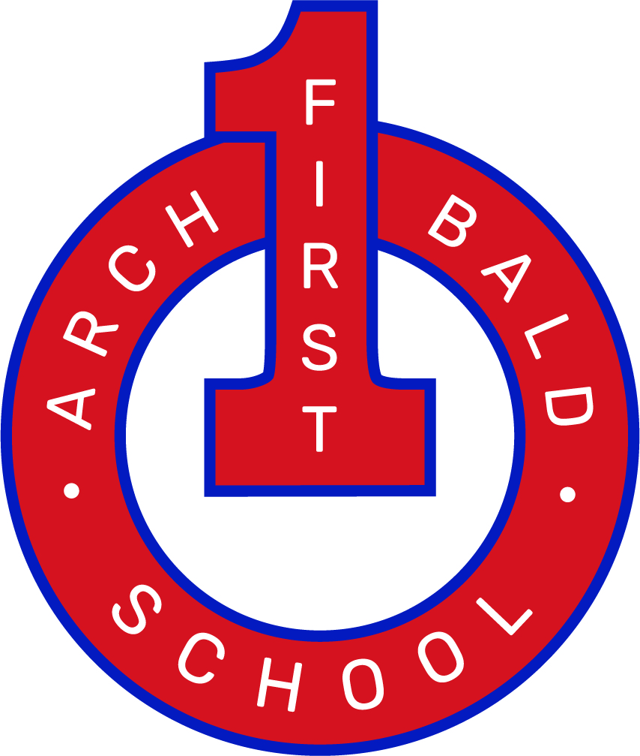
Music Subject Intent Statement

Curious |  | Caring | Creative | Courageous
Intent | At Archibald First School, we are MUSICIANS! We want our children to love music, have fun and learn together to become curious, caring, creative and courageous individuals. Our vision, at Archibald, is to give children access to an engaging and fun music curriculum reflecting the world they live in now, but at the same time giving them access to musical styles, traditions and genres throughout history. Children are able to listen and appraise a variety of musical styles alongside performing pieces and creating their own compositions through the use of instruments and technology. To achieve this, all children access a variety of musical games, songs, instruments and music workshops. We hope children continue to grow in courage as they progress through the musical curriculum and become passionate in their responses to music. Added to this, we want children to become more independent learners within this area, reflect upon their learning, develop resilience and curiosity within the musical world. As a school, these are our aims:  - To encourage awareness, enjoyment and appreciation of music in all its forms.  - To develop imagination and creativity.  - To help children of all abilities (including those with SEND) and from all cultures and backgrounds (including EAL, PP and FSM children) to develop positive, caring attitudes and to experience success and satisfaction in music.  - To offer opportunities to sing, perform, play instruments, compose, listen and appraise.  - To ensure that children are ready and prepared for the next stage of their musical education journey; that they are ‘middle school ready’.
Implementation | Children at Archibald participate in a weekly music lesson.  At Archibald, we make use of the online Musical resource Kapow for delivery of music across the school, this is supplemented by BBC 10 pieces, the Philharmonic resources for early learners, Singing School workshops provided by Newcastle Cathedral and term long specific tuned instrument tuition for all children in Y1-4. Children in nursery and reception classes also receive Piccolo workshops in the spring term.  Kapow planning is used by teachers to drive children’s development within music. Every year group will build upon the learning from prior year groups therefore developing depth of understanding and progression of skills. We follow the ‘condensed’ long term plan to ensure complete curriculum coverage but to also allow time for tuned instrument tuition, lessons that have been supplemented from other areas and in-depth studies of a broad range of composers and musicians. Our curriculum is in line with the non-statutory Model Music Curriculum and fully supports the National Curriculum.  Lessons provide opportunities for children to develop practical skills and progress by listening and appraising, singing, playing, composing, and performing.  We promote an enjoyment and foster interest of music through regular singing practise, musical workshops, and other extra- curricular opportunities such as Gosforth band, Gosforth voices, instrument tuition and singing and ukulele clubs.  Pupils experiencing difficulties will be given extra encouragement by working in a small group with the teacher/support staff or with a more musically able child.  As well as music lessons in class, children are encouraged to learn a range of instruments through external music providers NEMCO and take part in weekly singing assemblies.  Pupils are given the opportunity to listen to a range of music through various in  and out of school opportunities  - Performances take place within various school activities and are integral to the school ethos of ‘Having Fun, Learning Together’.  - Members of SLT lead regular key stage singing assemblies which include song learning and music appreciation.  - Instrumental groups will be encouraged to perform in Assembly whenever performances are ready to be heard.  - There will be an annual music evening for children to perform instrumental and vocal music.  - Children perform in Christmas celebrations and class assemblies.  - To appreciate live music and singing performances such as; Gosforth voices, Live Tales and the Tyne Theatre pantomime  - Each year group has a set of carefully selected Composers and musicians. The music associated with each is listened to appraised and reflected upon. These composers and musicians reflect a wide range of time periods, genders, cultures, ethnicities and musical styles.  EYFS  Through Expressive Arts, children are taught to sing songs, make music and dance. Children are given opportunities to experiment with ways of changing sound and develop an understanding of pulse, rhythm and pitch. Children follow a scheme of work from Kapow and enjoy listening and responding to different styles of music, learning to sing, joining in with nursery rhymes and action songs which leads to playing classroom instruments and performing for others. The Kapow programme is supplement with Piccolo workshops and lessons from the ‘Philharmonic Music for Early Years, The Gingerbread Man unit’. Children are also encouraged to use everyday objects to make music and create sound, children enjoy and experiment with sound using objects made from different materials such as wood, metal and plastic. Children experiment with water buts, kettles and pans, piping, guttering, bin lids and many different types of beaters.  Resources  We have a range of music equipment and resources that can easily be moved around the school.  - There are a set of glockenspiels and a number of other tuned instruments such as recorders, hand bells, ocarinas and Boomwackers. Ukuleles are loaned to the school from the Music Service North East.  - A portable sound system, Microphones and CD player available for use in class.  - The school class set of iPads have music apps installed.  - Access to Kapow resources are available to all staff.  - Our CD collection and song books are kept on the system and a hard copy in the subject leader’s classroom. The CD collection will be extended as funding allows. Where possible CDs purchased for the school are copied to the network to be shared across the school. Links to other appropriate sources of recording (e.g. YouTube and Spotify etc. are regularly shared
Impact | The impact of this Music curriculum is that children will love music, in all its glorious forms. They will understand that music can help them; to relax, to concentrate, to have fun, to make friends, to understand more about themselves and the world around them. They will share their love of music with others and understand that everyone is entitled to their own views and opinions. There is no ‘bad music’ but there may be music that you don’t enjoy personally and that is ok.  Our curriculum will also lead to at least good progress over time across key stages relative to a child’s individual starting point and their progression of skills, children of all abilities, backgrounds and cultures including those identified as SEND, PP and EAL will make progress in line with their peers. Those children with a particular interest or aptitude in music will be given the opportunity to extend their education in a variety of ways, for example, orchestral groups, singing club, instrumental performances in assembly. Children will therefore be expected to leave Archibald reaching at least age expected expectations for Music. Our Music curriculum will hopefully foster a love and increasing enthusiasm for the subject amongst our children, and a potential for life- long musical study.

